 VINOD SIR’S GROUP TUTION

MARKS: 21 CIVICS-VIII TIME: 1 Hr. 30 Mins.

Q. 1: Fill in the blanks for the following: [3]
1. The Winter session of Maharashtra Legislature takes place at ............. .
2. The ............... appoints the Governor.
3. The right to summon the state legislature lies with the ...............

Q. 2: Write short notes for the following: [4]

1. Governor 2. Functions of the Chief Minister

Q. 3: Answer the following in brief for the following: (Any 3) [6]

1. Enumerate the functions of the Speaker of the Vidhan Sabha (Legislative Assembly).
2. Why did the Constitution adopt a federal system for India?
3. What are the considerations of the Chief Minister while allocation of portfolios?
4. Explain the role of the ministers and civil servants in the efficient administration of the department.
5. Explain how the bureaucracy provides stability to the political system.

Q. 4: Explain the following statements with reasons. [4]
1. Reservation policy is followed even in civil services.
2. It is necessary for civil servants to be politically neutral.

Q. 5: Complete the following: [4]

1. 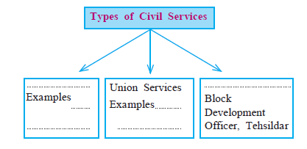
2. 